CYCLE TEST-2
GRADE – X MARK - 20
SUBJECT – CHEMISTRY(86) TIME – 40 MINS
1. How will you test for a gas which is liberated when HCL reacts with an active metal?(1m)
2. When fresh milk is changed into curd will its pH value increase or decrease? Why?(1m)
3. Arrange these in increasing order of their pH values- NaOH, blood, lemon juice. (1m)
4. Give Arrhenius definition of an acid and a base. (1m)
5. Why does 1 M HCL solutions have a higher concentration of H⁺ ions than 1M CH₃COOH solution? (1m)
6. What are strong and weak acids? In the following list of acids, separate strong acids from weak acids. Hydrochloric acid, citric acid, acetic acid, nitric acid, formic acid, sulphuric acid.(3m)
7. When zinc metal is treated with a dilute solution of a strong acid, a gas is evolved, which is utilised in the hydrogenation of oil. Name the gas evolved. Write the chemical equation of the reaction involved and also write a test to detect the gas formed.(3m)
8. Identify the compound X based on the reactions given below. Also, write the name and chemical formulae of A, B and C.(3m)
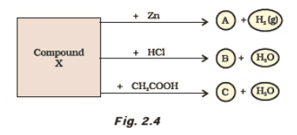
9. How will you obtain sulphuric acid from acidic oxide?
10. Show ionically why sulphuric acid and acetic acid are called acids?

